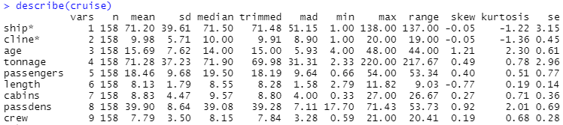

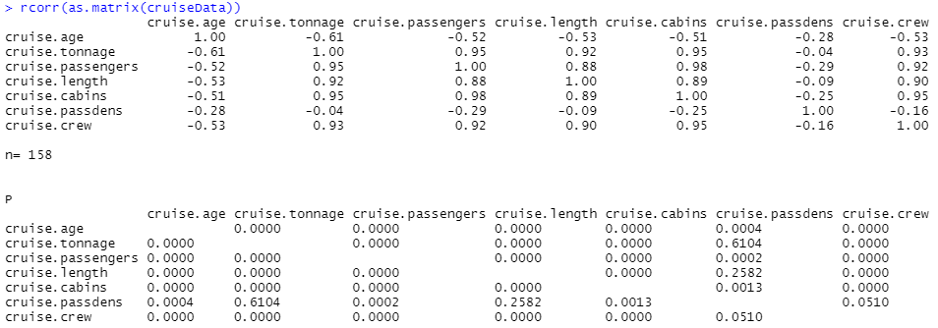

These are the descriptive statistics that we started off looking at the data set with. The first command allows us to see some basic information about each of the variables, while the second command allows us to see the correlation between each of the variables. The important value in the rcorr() command is the p-value, decreasing to 0.0 as the two variables have stronger correlation. This gives us a good idea on what variables to pay attention to. One thing that we noted before moving on was the differences in passenger density when compared to tonnage and length, length appearing to have more control over the passenger density than the tonnage does.

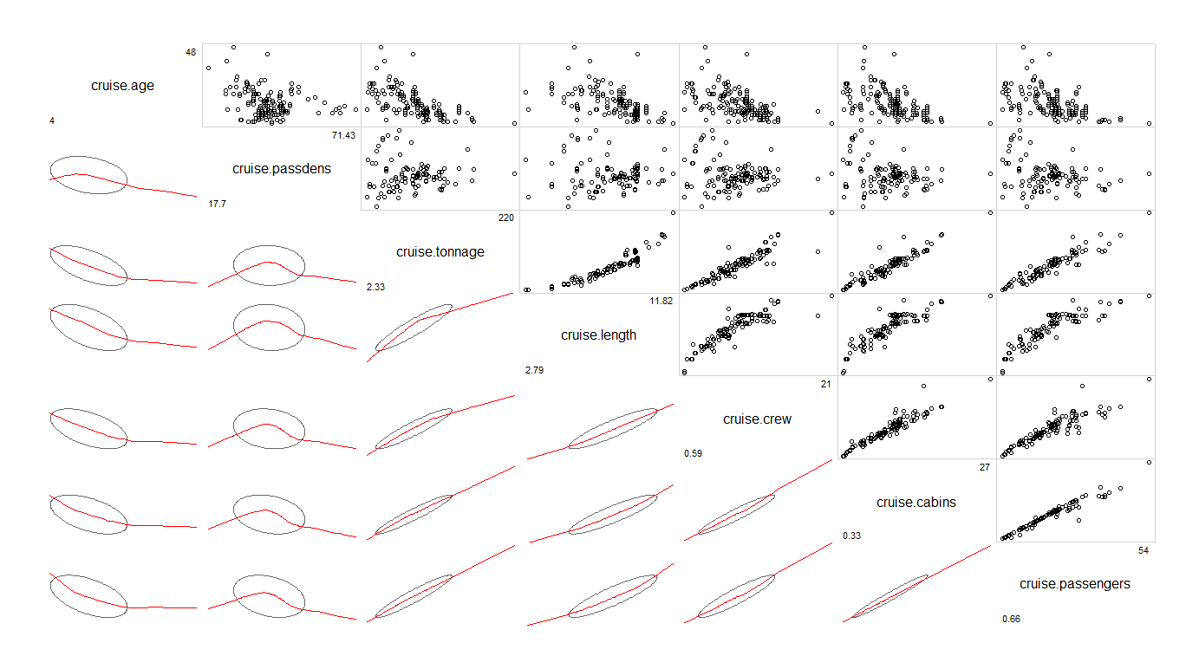

After seeing many correlated variables from the rcorr() command, we used the corrgram() command to have a visual to go along with the correlations we observed. Many correlations appear to have similar graphs, however the age and passenger density variables had significantly different graph shapes. We also noticed that the shapes of the passenger density had very similar graphs for the correlations to other variables. Below are larger graphs of the passenger density.

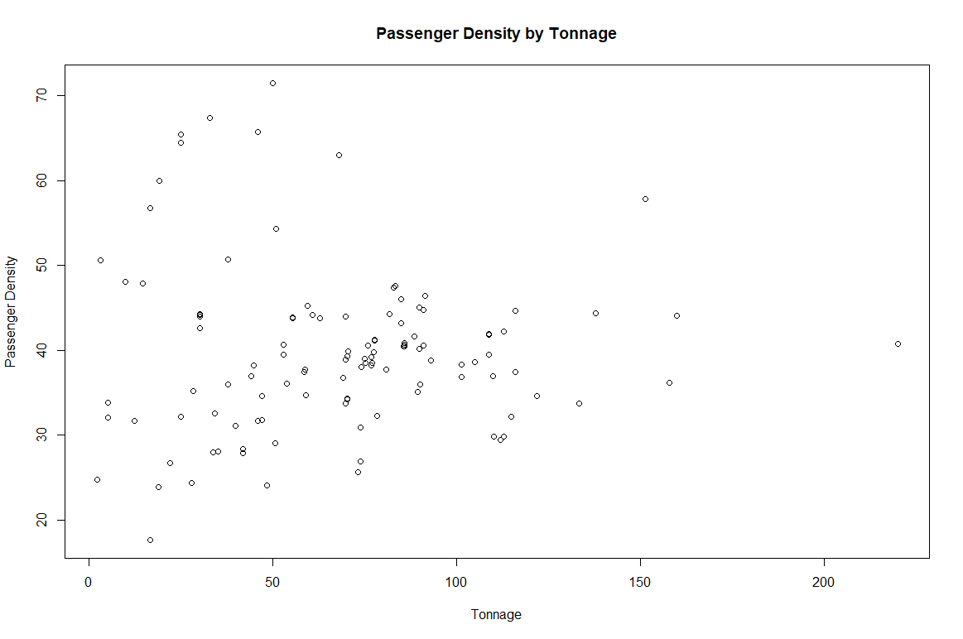

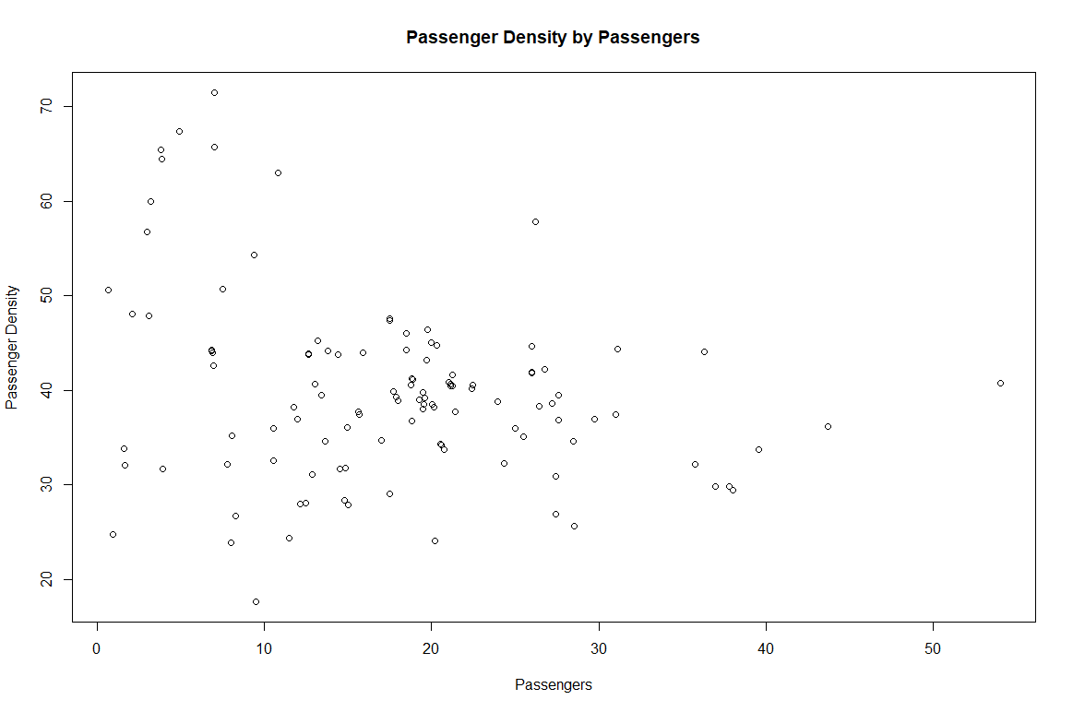

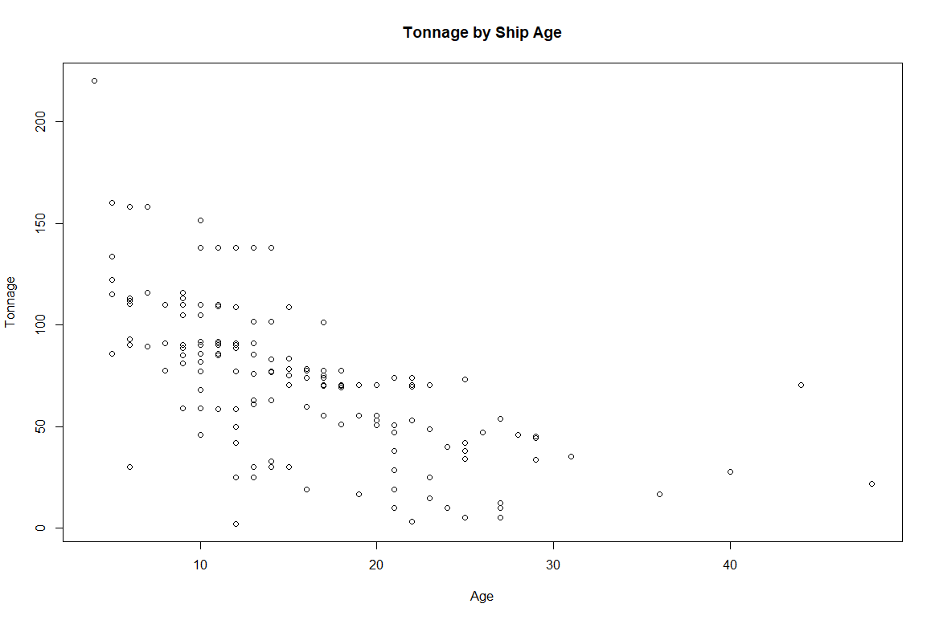

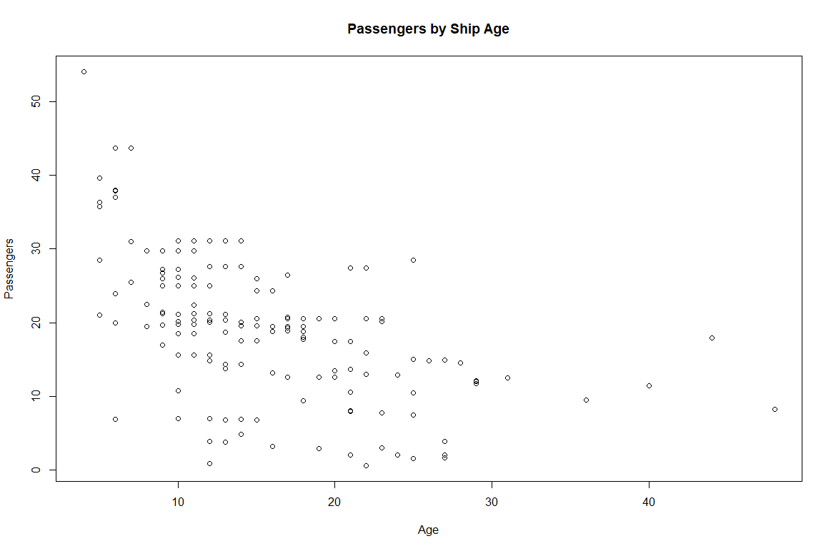

Another variable with different graphs from the corrgram() command was the age variable. The correlations showed the youngest ships having the highest statistics for the other variables, such as tonnage and number of passengers above. We can so far conclude that newer ships are bigger and therefore will have a larger capacity in each variable simply by being larger ships.

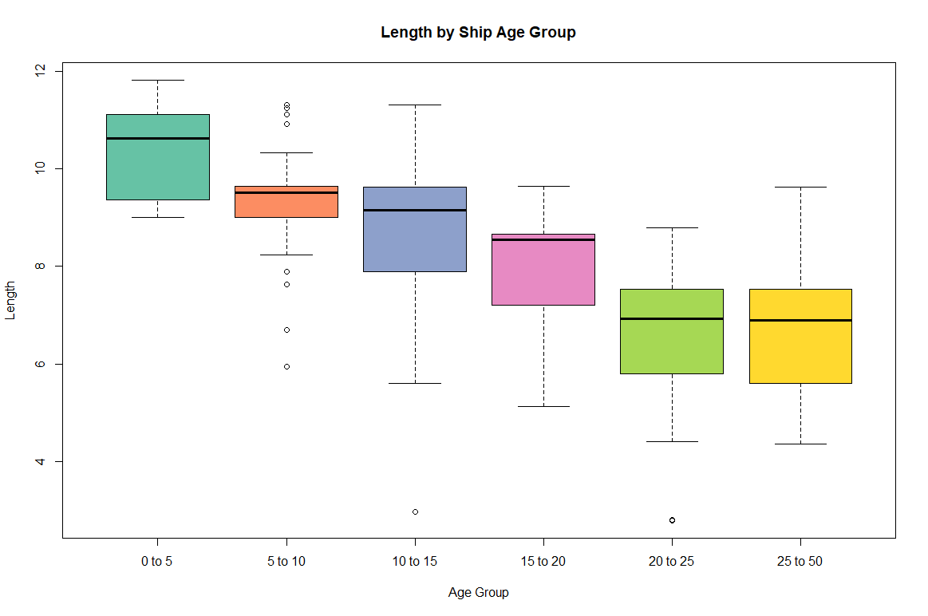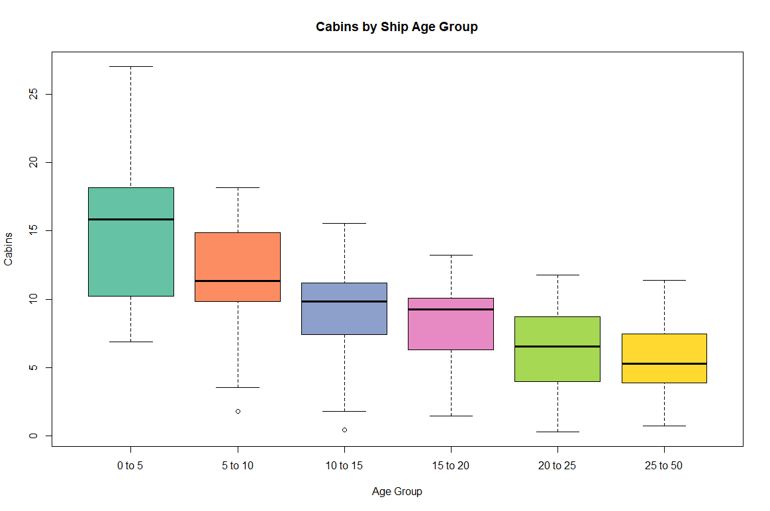

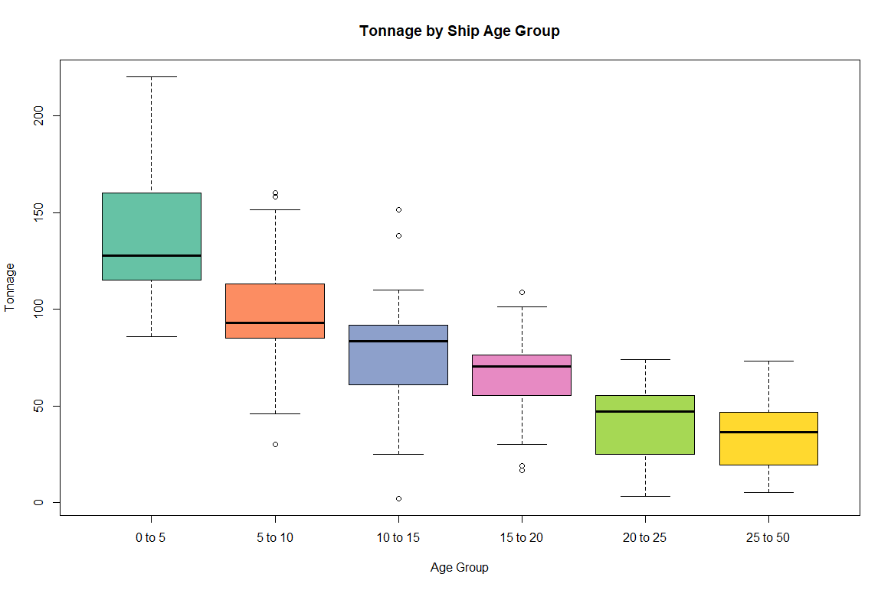

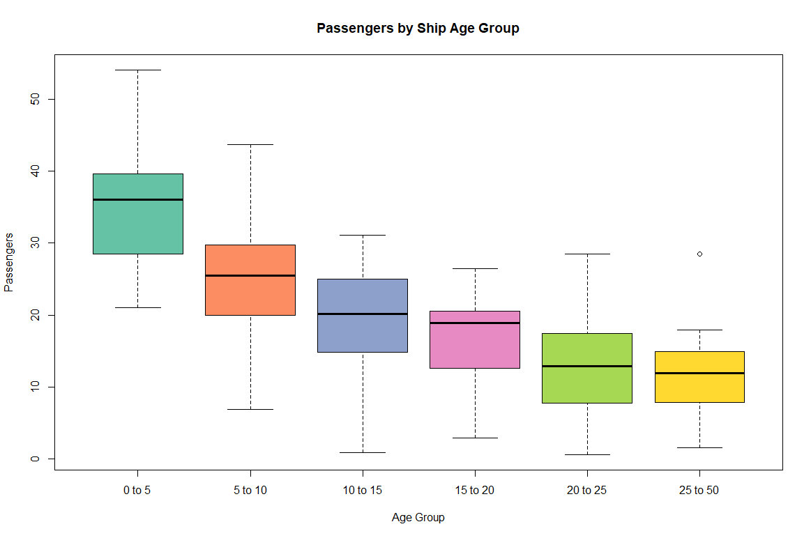

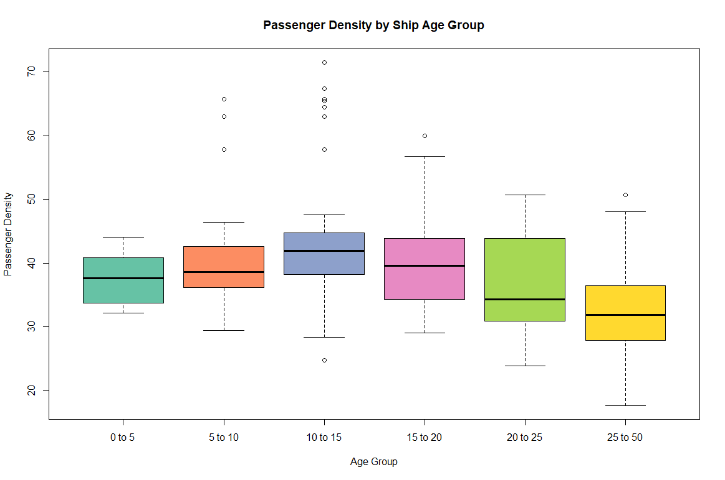

We subset the age variable into several smaller sets based on age ranges, using intervals of 0 to 5 years old, 5 to 10, 10 to 15, 15 to 20, 20 to 25, and 25 to 50. What we noticed is that the newest ships did not have the highest in passenger density, unlike all of the other variables we compared. The highest passenger density lies within the middle-aged range for the ships, from 10 to 20 years old. This would lead us into further research on the cruise ships in the age groups to help in determining why the passenger density was different from every other variable.

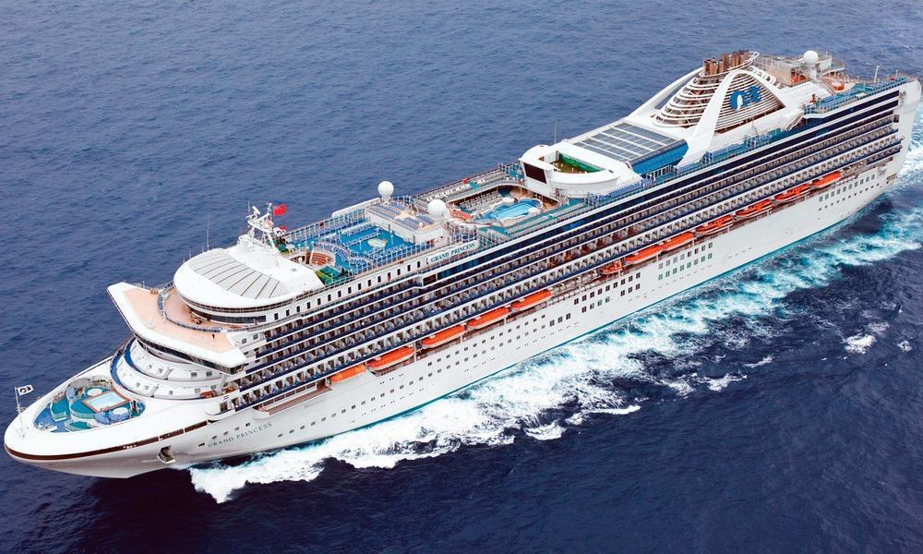

Princess Grand Cruise Ship, 15 years old

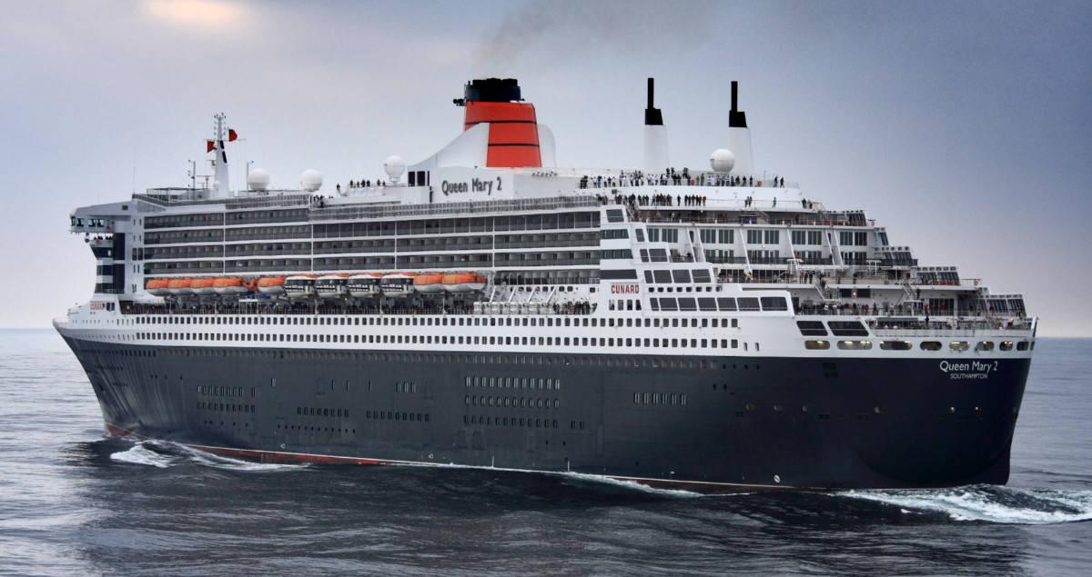

Cunard Queen Mary 2, 10 years old

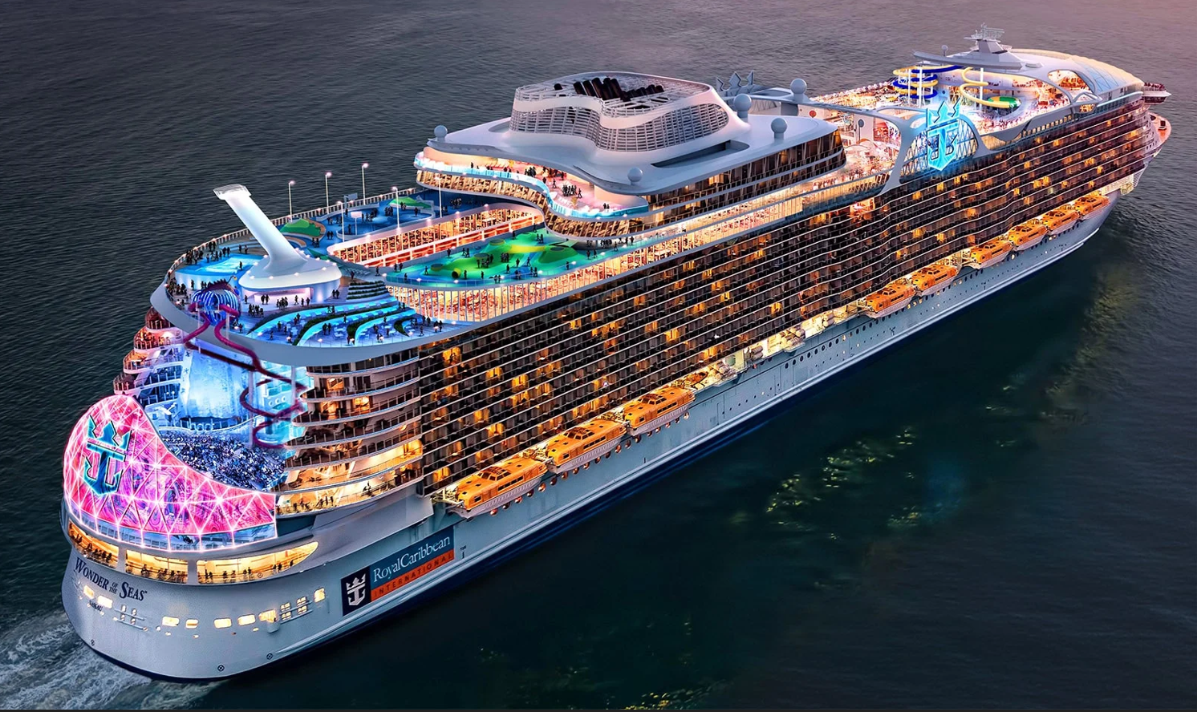

Royal Caribbean Oasis, 4 years old

These are the largest ships from the age groups 15 to 20, 10 to 15, and 0 to 5. One conclusion we could draw from looking at the ships is the difference in attractions that are a part of the ship. The Grand cruise ship has some additional entertainment areas on the top, but consists largely of cabins for passengers, meaning more people and a higher density. The Queen Mary 2 cruise ship follows a similar design, with a majority of the space being used for cabins. The Oasis cruise ship has significantly larger sections on the ship for entertainment or other purposes than cabins. Although the Oasis has a larger amount of passengers, this is due to the massive size of the ship, meaning there is more space and decreasing the passenger density. We can conclude that newer ships have the design philosophy of focusing on fitting as many attractions and places for passengers to spend money while simultaneously increasing the size to fit thousands of passengers to use the attractions.

Conclusion

Many of the variables show strong correlation within the cruise ship data set. However, passenger density is an outlier from the other variables in that it does not increase with the more recent ships like all other variables. Conclusions can be made from looking at the ships themselves. The largest ship from the most recent age range, and two middle age ranges, show that the newest ship is not only significantly larger, but is able to hold many attractions that are not typically seen on other boats. The size of the boat allows for more passengers than other boats, while fitting all of the attractions. We can conclude that this design philosophy with new cruise ships is responsible for the passenger density decreasing with newer ships. This means that cruise ships have become less about traveling, and more about the cruise ship itself becoming the destination. Through having more to do on the ship and having many places for the ship to make revenue from the passengers on the boat, there is less need for passengers to want to leave the ship to go to the destinations that the ship travels to.

R Studio Code

